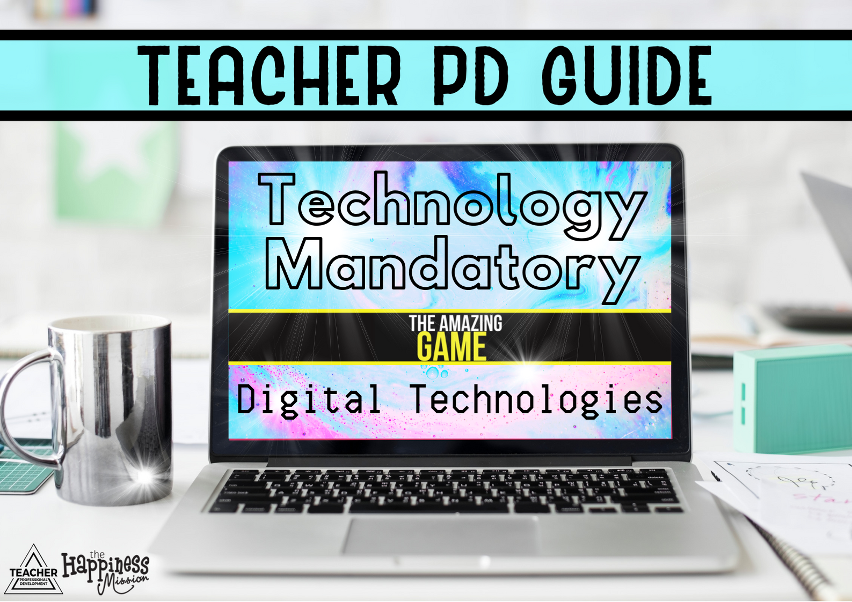

Welcome to Technology Mandatory
Digital Technologies

We hope you have an amazing day here with us and walk away feeling as though you have gained a great deal of value from this course.
This course contributes to 5.0 hours of NESA Registered Teacher Professional Development. It addresses standards 2.1.2 and 6.2.2 at Proficient Teacher accreditation level in NSW, Australia. Please don’t forget to sign the attendance sheet and add your Teacher Accreditation Number so we can provide this information to NESA.
The feedback forms you fill in go to NESA too. Please ensure you clearly print your names on them as well. You will also receive a certificate of completion at the end of the day.
We know how difficult it is to get time off school; the organisation required as well as the lesson planning and we are so grateful you could make it here today. We want it to be not just a professional development experience but also a chance to network with likeminded teachers.
Here are some links that you’ll need.

Feel free to join our community on Facebook: https://www.facebook.com/groups/FoodTechnologyTeachers/
App Lab:
https://code.org/educate/applab
Assignment 2 Example (Google Slides):
https://docs.google.com/presentation/d/1MHbB6Gz99zSOTZk8sxzUMF5fvu0z3B7rGXsYHDhytu8/edit?usp=sharing

We wholeheartedly appreciate your attendance and hope we can stay in contact after the course.

With kindness and gratitude,

Carly, Tresne and Lou
Teacher Professional Development
info@tpd.edu.au

Digital Technologies
Indicative Hours

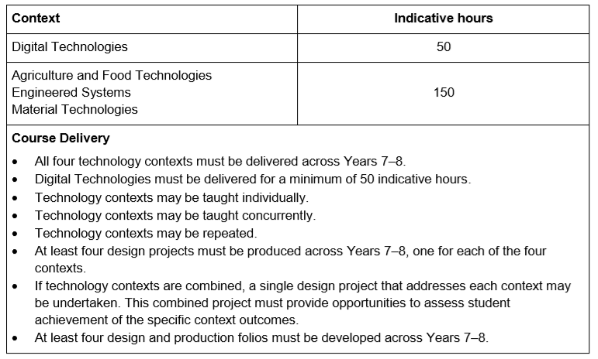

In this course we will be looking at the prospect of teaching the Digital Technologies content over a semester (20 weeks/2 terms). However, you may choose to split the course amongst the other context areas in Technology Mandatory.
If we split the indicative hours for Digital Technologies across a semester (20 weeks/2 terms) we can adequately cover requirements. Many schools will wish to do combined units, for example Digital Technologies and Materials Technologies or run a term (approx.25 hours) of Digital Technologies and split the remaining 25 hours amongst other subjects in Technology Mandatory.
MIT AppInventor
Positives | Negatives
- It was set up as part of the Hour of Code effort, so it can make a great introduction for students to coding.  - Resources also include concept cards and maker cards which can be printed to assist students.  - Drag and drop interface.  - Quickly opens in any web browser.  - Free. | - Apps created only run through android mobile devices.  - Block based coding environment which does not allow you to meet the general purpose programming language dot point.
Is an online app creation platform first developed by Google and maintained by MIT.
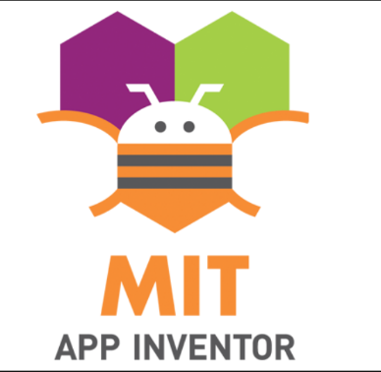

Swift Playgrounds
Swift Playgrounds (for iPad) starts out like a puzzle game where players have to figure out how to enter and test code until they find the right solution. The code they learn to use is in Apple's Swift language, which real developers use to create iOS apps.
Positives | Negatives
- Colourful and intuitive interface.  - Flexible and diverse challenges.  - No internet access required after downloading the app.  - Step by step lessons and puzzles available to build coding knowledge and skills.  - Can build in other programs.  - Build from a blank project and try out different coding concepts.  - Free. | - Can only be used on the iPad.  - Block based coding environment which does not allow you to meet the general purpose programming language dot point.

Thunkable
Positives | Negatives
- Builds IOS and Android Apps.  - Simple, easy to use interface.  - Free.  - Published Apps can be uploaded to IOS or Google Play store. | - No coding involved.  - Block based coding environment which does not allow you to meet the general purpose programming language dot point.
Thunkable is an app making website. It is created by just drag and drop interface without any coding.

Classroom
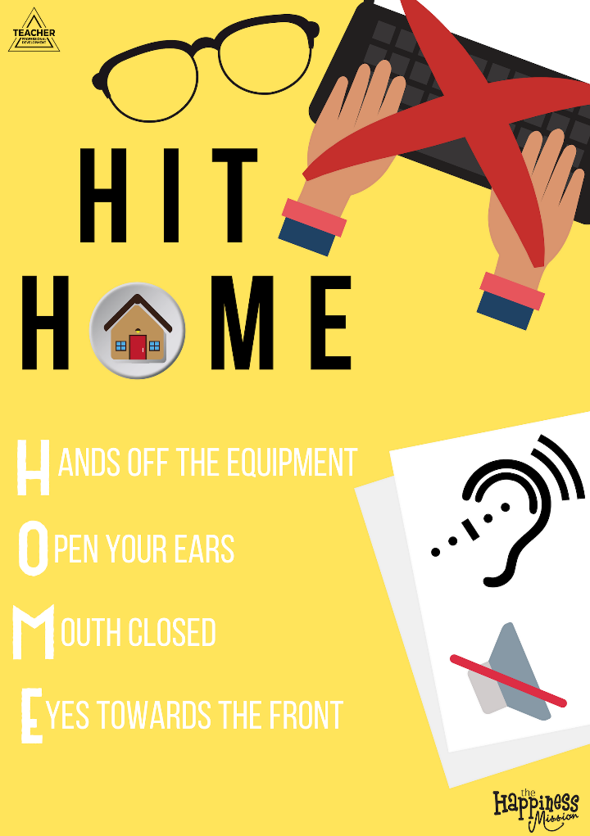
These websites offer some tips for introducing coding to your classroom:
- https://d1e2bohyu2u2w9.cloudfront.net/sites/default/files/tlr-asset/document-coding-tip-sheet-updated-0.pdf

- https://blogs.edweek.org/edweek/education_futures/2017/06/9_tips_for_teaching_coding_in_the_classroom.html

We have developed this poster (HIT HOME) for use in your classroom if you choose to use it. The idea is that if you introduced this concept into your classroom you as the teacher would say “Hit Home” to your students and they would respond with removing their hands from the equipment, opening their ears, closing their mouth and focusing their eyes towards the front.

This could be a quick and simple way to gain the attention of your students within your classroom when they are coding.

Curriculum

Cross-Curriculum Priorities:
Thinking skills:
Systems thinking – ST Systems thinking is an understanding of how related objects or components interact to influence how a system functions. Students are provided with opportunities to recognise the connectedness of, and interactions between phenomena, people, places and events in local and wider contexts and to consider the impact of their decisions. Understanding the complexity of systems and the interdependence of components is important for scientific research and for the creation of solutions to technical, economic and social issues.

Design thinking – DT Design thinking involves a process where a need or opportunity is identified and a design solution is developed. The consideration of economic, environmental and social impacts that result from designed solutions are core to design thinking. Design thinking methods can be used when trying to understand a problem, generate ideas and refine a design based on evaluation and testing.

Computational thinking – CT Computational thinking is a process where a problem is analysed and solved so that a human, machine or computer can effectively implement the solution. It involves using strategies to organise data logically, break down problems into parts, interpret patterns and design and implement algorithms to solve problems.
Aboriginal and Torres Strait Islander histories and cultures
Asia and Australia’s engagement with Asia
Sustainability

General Capabilities:
Critical and creative thinking
Ethical understanding
Information and communication technology capability
Intercultural understanding
Literacy
Numeracy
Personal and social capability

Identified Important Learning:
Civics and citizenship
Difference and diversity
Work and enterprise

Literacy

Sub-element | Level 5 Typically, by the end of Year 8, students: | Activity in the Unit
Navigate, read and view learning area texts | Navigate, read and view a variety of challenging subject-specific texts with a wide range of graphic representations | - Tube map challenge  - Australian Bureau of statistics (ABS), train timetables, Bureau of Meteorology (BoM)  - Assessment task 1: Planning Questions  - What is IS? PowerPoint
Listen and respond to learning area texts | Listen to extended spoken and audio texts, respond to and interpret stated and implied meanings, and evaluate information and ideas | - Binary Videos  - TCP/IP Activity (Data Dash)  - What is IS? PowerPoint
Interpret and analyse learning area texts | Interpret and evaluate information, identify main ideas and supporting evidence, and analyse different perspectives using comprehension strategies | - Geek Speak  - Unpacking the world of literacy  - The English language starter  - Evaluate that App  - Hardware Globetrotter
Compose spoken, written, visual and multimodal learning area texts | Compose and edit longer sustained learning area texts | - Binary explanation  - Assignment 1  - Assignment 2
Use language to interact with others | Use pair, group and class discussions and formal and informal debates as learning tools to explore ideas, test possibilities, compare solutions, rehearse ideas and arguments in preparation for creating texts | - Hardware Globetrotter  - Are you stuck?  - UX (User Experience)  - Tube Map Challenge  - Travelogged
Deliver presentations | Plan, research, rehearse and deliver presentations on learning area topics, sequencing selected content and multimodal elements for accuracy and their impact on the audience | - Assignment 2: Elevator Pitch  - Extension: App launch video
Use knowledge of text cohesion | Use knowledge of word functions to make connections in texts | - Unpacking the World of Literacy  - Geek Speak  - Digital Technology Terminology Poster Pack
Use knowledge of sentence structures | Control a range of simple, compound and complex sentence structures to record, explain, question, argue, describe and link ideas, evidence and conclusions | - Leading Digital Technology Professionals  - Viral Web  - Binary explanation  - Narrative literacy task: TCP/IP
Express opinion and point of view | Use language to evaluate an object, action or text, and language that is designed to persuade the reader/viewer | - Evaluate that App  - Assignment 2  - Testing & Evaluating  - UI (User Interface)
Understand learning area vocabulary | Use a wide range of new specialist and topic vocabulary to contribute to the specificity, authority and abstraction of texts | - Digital Technology Terminology Pack  - Geek Speak  - Branching, Boolean, Iteration, Variables, If/Else Statement
Use spelling knowledge | Spell specialist topic words and use knowledge of word origins, base words, prefixes and suffixes and unusual letter combinations to spell correctly | - Assignment 1  - Assignment 2  - Expectations through out the student work booklets as well as the Get Appy design folio
Understand how visual elements create meaning | Analyse the effects of different visual elements upon the reader/viewer, and how visual texts such as advertisements and informative texts draw on and allude to other texts to enhance meaning | - Wireframes  - App development (Canva screens)

Numeracy

Sub-element | Level 5 Typically, by the end of Year 8, students: | Activity in the Unit
Understand and use numbers in context | Compare, order and use positive and negative numbers to solve everyday problems | - Binary Bingo  - Binary conversion (Data Dash)
Estimate and calculate | Solve complex problems by estimating and calculating using efficient mental, written and digital strategies | - What colour is this (hexadecimal identification)
Use money | Identify and justify ‘best value for money’ decisions | - Travel Account Excel Document  - Passport with Perks  - Detour Cards  - Express Pass Cards
Recognise and use patterns and relationships | Identify trends using number rules and relationships | - Tracing Algorithms in App Lab  - Australian Bureau of statistics (ABS) , train timetables, Bureau of Meteorology (BoM)
Apply proportional reasoning | Solve problems using simple percentages, ratios and rates | - Conversion Confusion
Visualise 2D shapes and 3D objects | Visualise, describe and apply their understanding of the features and properties of 2D shapes and 3D objects | - Wire frames  - App development (Canva)
Interpret maps and diagrams | Create and interpret 2D and 3D maps, models and diagrams | - Branching Break  - Tube Map Challenge  - Whac-A-Venture branching algorithm
Interpret data displays | Compare, interpret and assess the effectiveness of different data displays of the same information | - Assignment 2 Graph Data representation
Interpret chance events | Describe and explain why the actual results of chance events are not always the same as expected results | - Assignment 2  - App Lab Design
Operate with clocks, calendars and timetables | Use 12- and 24-hour systems within a single time zone to solve time problems, and place personal and family events on an extended time scale | - Tube Map Challenge

ICT

Sub-element | Level 5 Typically, by the end of Year 8, students: | Activity in the Unit
Recognise intellectual property | Apply practices that comply with legal obligations regarding the ownership and use of digital products resources | - Viral Web  - App Lab Design
Apply digital information security practices | Independently apply strategies for determining the appropriate type of digital information suited to the location of storage and adequate security for online environments | - App Lab design  - Assignment 1  - Assignment 2
Apply personal security protocols | Identify and value the rights to identity, privacy and emotional safety for themselves and others when using ICT and apply generally accepted social protocols when using ICT to collaborate with local and global communities | - Email Phishing Scam Danger  - Viral Web  - Pick the scam  - Roadblock questions  - Mandy Davis Campervan copyright
Identify the impacts of ICT in society | Explain the benefits and risks of the use of ICT for particular people in work and home environments | - Safety First  - Data Dash  - Geek Speak
Define and plan information searches | Use a range of ICT to analyse information in terms of implicit patterns and structures as a basis to plan an information search or generation | - Bureau of Statistics Paddle Pop People
Locate, generate and access data and information | Locate, retrieve or generate information using search facilities and organise information in meaningful ways | - Assignment 2  - Australian Bureau of Statistics (ABS) , train timetables, Bureau of Meteorology (BoM)
Select and evaluate data and information | Assess the suitability of data or information using appropriate own criteria | - Passport with Perks  - Assignment 2  - What is IS?
Generate ideas, plans and processes | Use appropriate ICT to collaboratively generate ideas and develop plans | - UX (User Experience)  - Travelogged  - Code Collaboration
Generate solutions to challenges and learning area tasks | Design and modify simple digital solutions, or multimodal creative outputs or data transformations for particular audiences and purposes following recognised conventions | - App Design  - Assignment 2
Collaborate, share and exchange | Select and use appropriate ICT tools safely to lead groups in sharing and exchanging information, and taking part in online projects or active collaborations with appropriate global audiences | - Safety First  - Travelogged
Understand computer mediated communications | Understand that there are various methods of collaboration through computer mediated communications that vary in form and control | - TCP/IP  - Evaluate that App
Select and use hardware and software | Independently select and operate a range of devices by adjusting relevant software functions to suit specific tasks, and independently use common troubleshooting procedures to solve routine malfunctions | - App Lab Design  - Wave Invoice  - Assignment 2
Understand ICT systems | Identify and compare networked ICT system components including between hardware, software and data | - TCP/IP  - Hardware Globetrotter  - Data Dash
Manage digital data | Manage and maintain data for groups of users using a variety of methods and systems | - Passport with Perks  - Travel Account Excel Document

Critical and Creative Thinking
Sub-element | Level 5 Typically, by the end of Year 8, students: | Activity in the Unit
Pose questions | Pose questions to probe assumptions and investigate complex issues | - Data interpretation  - Travelogged  - Viral Web
Identify and clarify information and ideas | Clarify information and ideas from texts or images when exploring challenging issues | - TCP/IP  - Conditional Branching Basics  - Boolean  - Gangnam style breaks YouTube
Organise and process information | Critically analyse information and evidence according to criteria such as validity and relevance | - Viral Web  - Passport with Perks  - Assignment 2
Imagine possibilities and connect ideas | Draw parallels between known and new ideas to create new ways of achieving goals | - Mind blowing emerging technologies  - Hardware Globetrotter  - Hardware Prediction  - UX (User Experience)
Consider alternatives | Generate alternatives and innovative solutions, and adapt ideas, including when information is limited or conflicting | - Wire frames  - App Lab design
Seek solutions and put ideas into action | Predict possibilities, and identify and test consequences when seeking solutions and putting ideas into action | - Modelling code in App Lab (model objects and events)
Think about thinking (metacognition) | Assess assumptions in their thinking and invite alternative opinions | - Code Collaboration  - Travelogged  - Evaluate that App
Reflect on processes | Evaluate and justify the reasons behind choosing a particular problem-solving strategy | - Assignment 2  - Evaluate that App  - Viral Web
Transfer knowledge into new contexts | Justify reasons for decisions when transferring information to similar and different contexts | - Assignment 2  - App Lab design
Apply logic and reasoning | Identify gaps in reasoning and missing elements in information | - TCP/IP  - Binary explanation  - Conditional Branching Basics
Evaluate procedures and outcomes | Explain intentions and justify ideas, methods and courses of action, and account for expected and unexpected outcomes against criteria they have identified | - Criteria to Evaluate Success  - Assignment 2  - Hardware Globetrotter  - App Design
Capability
Personal &Social

Sub-element | Level 5 Typically, by the end of Year 8, students: | Activity in the Unit
Recognise emotions | Examine influences on and consequences of their emotional responses in learning, social and work related contexts | - Viral Web  - Mandy Davis Campervan copyright
Recognise personal qualities and achievements | Make a realistic assessment of their abilities and achievements, and prioritise areas for improvement | - Appy Awards  - Assignment 2  - Student self-evaluation  - Evaluation
Understand themselves as learners | Identify and choose a range of learning strategies appropriate to specific tasks and describe work practices that assist their learning | - Reach, stretch and extension options provided throughout the unit
Develop reflective practice | Predict the outcomes of personal and academic challenges by drawing on previous problem solving and decision making strategies and feedback from peers and teachers | - Assignment 1  - Assignment 2  - Code Collaboration  - Whac-A-Venture Branching Algorithm  - Wire frames  - App development (Canva frames)  - App Design  - App Lab challenge
Express emotions appropriately | Forecast the consequences of expressing emotions inappropriately and devise measures to regulate behaviour | - Viral Web  - U-turn cards  - The Amazing game board
Develop self-discipline and set goals | Predict possibilities, and identify and test consequences when seeking solutions and putting ideas into action | - Model objects or events  - Trace algorithms  - Whac-a-venture branching algorithm  - App Lab challenge
Work independently and show initiative | Critique their effectiveness in working independently by identifying enablers and barriers to achieving goals | - Student self-evaluation
Become confident, resilient and adaptable | Assess, adapt and modify personal and safety strategies and plans, and revisit tasks with renewed confidence | - Viral Web  - Safety First
Appreciate diverse perspectives | Acknowledge the values, opinions and attitudes of different groups within society and compare to their own points of view | - Evaluate that App  - Paddle Pop People Bureau of Statistics (BoM)
Contribute to civil society | Analyse personal and social roles and responsibilities in planning and implementing ways of contributing to their communities | - Assignment 1  - Assignment 2
Communicate effectively | Analyse enablers of and barriers to effective verbal, nonverbal and digital communication | - Assignment 2  - Team communication on the board game
Work collaboratively | Assess the extent to which individual roles and responsibilities enhance group cohesion and the achievement of personal and group objectives | - Detour cards  - Code Collaboration  - Travelogged
Make decisions | Assess individual and group decision making processes in challenging situations | - Detour cards
Negotiate and resolve conflict | Assess the appropriateness of various conflict resolution strategies in a range of social and work-related situations | - HIT Home

Understanding
Ethical

Sub-element | Level 5 Typically, by the end of Year 8, students: | Activity in the Unit
Recognise ethical concepts | Analyse behaviours that exemplify the dimensions and challenges of ethical concepts | - English Language Brain Warm-up
Reason and make ethical decisions | Analyse inconsistencies in personal reasoning and societal ethical decision making | - Viral Web
Consider consequences | Investigate scenarios that highlight ways that personal dispositions and actions can affect consequences | - Viral Web  - Email Phishing Scam Danger
Reflect on ethical action | Analyse perceptions of occurrences and possible ethical response in challenging scenarios | - Detour Cards
Explore rights and responsibilities | Analyse rights and responsibilities in relation to the duties of a responsible citizen | - Pick the Scam
Consider points of view | Draw conclusions from a range of points of view associated with challenging ethical dilemmas | - Detour cards  - Viral Web
Sub-element | Level 5 Typically, by the end of Year 8, students: | Activity in the Unit
Communicate across cultures | Explore ways that culture shapes the use of language in a wide range of contexts | - The English Language Brain Warm-up
Empathise with others | Imagine and describe the feelings and motivations of people in challenging situations | - Viral Web  - Find your partner flags
Intercultural Understanding

Curriculum
https://www.australiancurriculum.edu.au/f-10-curriculum/cross-curriculum-priorities/aboriginal-and-torres-strait-islander-histories-and-cultures/
Learning Area Statement: Technologies
Aboriginal and Torres Strait Islander histories and cultures
Students will identify the interconnectedness between technologies and Identity, People, Culture and Country/Place. They will explore, understand and analyse how this intrinsic link guides Aboriginal and Torres Strait Islander Peoples in sustaining environments, histories, cultures and identities through / by creating appropriate and sustainable solutions.
Asia and Australia’s engagement with Asia (not included in Digital Technologies specific dot points)
Students are able to explore traditional, contemporary and emerging technological achievements in the countries of the Asia region. They investigate the contributions that Australia has made and is making to create products and services that meet a range of needs in the Asia region and can examine the contributions that peoples of the Asia region have made and continue to make to global technological advances. Students explore Australia’s rich and ongoing engagement with the peoples and countries of Asia to create appropriate and sustainable products and services that meet personal, community, national, regional and global needs and reflect intercultural, creative and critical thinking.
Sustainability
Technologies enables consideration of preferred futures. When students identify and critique a problem, need or opportunity; generate ideas and concepts; and create solutions, they give prime consideration to sustainability by anticipating and balancing economic, environmental and social impacts. The curriculum focuses on the knowledge, understanding and skills necessary to design for effective sustainability action taking into account issues such as resource depletion and climate change. The learning area gives students opportunities to explore their own and competing viewpoints, values and interests. Understanding systems enables students to work with complexity, uncertainty and risk; make connections between disparate ideas and concepts; self-critique; and propose creative solutions that enhance sustainability. Students reflect on past and current practices and assess new and emerging technologies from a sustainability perspective.

